Sample problems – Exam2 Fall 2013

1. A highway curve has a radius of 0.14 km and is unbanked. A car weighing 12 kN goes around the curve at a speed of 24 m/s without slipping. What is the magnitude of the horizontal force of the road on the car?

|  |  |
| --- | --- |
| a. | 12 kN |
| b. | 17 kN |
| c. | 13 kN |
| **d.** | **5.0 kN** |
| e. | 49 kN |

2. If *F* = 8.0 N and *M* = 1.0 kg, what is the tension in the connecting string? The pulley and all surfaces are frictionless.

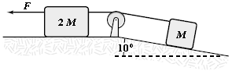

|  |  |
| --- | --- |
| a. | 4.1 N |
| b. | 3.5 N |
| **c.** | **3.8 N** |
| d. | 3.1 N |
| e. | 4.8 N |

3. A box rests on the (horizontal) back of a truck. The coefficient of static friction between the box and the surface on which it rests is 0.24. What maximum distance can the truck travel (starting from rest and moving horizontally with constant acceleration) in 3.0 s without having the box slide?

|  |  |
| --- | --- |
| a. | 14 m |
| **b.** | **11 m** |
| c. | 19 m |
| d. | 24 m |
| e. | 29 m |

4. At an instant when a 4.0-kg object has an acceleration equal to  m/s2, one of the two forces acting on the object is known to be  N. Determine the magnitude of the other force acting on the object.

|  |  |
| --- | --- |
| a. | 2.0 N |
| **b.** | **13 N** |
| c. | 18 N |
| d. | 1.7 N |
| e. | 20 N |

5. Two bodies, A and B, collide as shown in Figures I and II below.

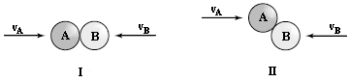

Which statement is true?

|  |  |
| --- | --- |
| a. | They exert equal and opposite forces on each other in I but not in II. |
| b. | They exert equal and opposite force on each other in II but not in I. |
| **c.** | **They exert equal and opposite force on each other in both I and II.** |
| d. | The forces are equal and opposite to each other in I, but only the components of the forces parallel to the velocities are equal in II. |
| e. | The forces are equal and opposite in I, but only the components of the forces perpendicular to the velocities are equal in II |

6. . A rock attached to a string swings in a vertical circle. Which free body diagram could correctly describe the force(s) on the rock when it is at the highest point?

|  |  |  |  |  |  |  |  |  |  |
| --- | --- | --- | --- | --- | --- | --- | --- | --- | --- |
| a. |  | b. |  | c. |  | d. |  | e. |  |

ANS: C

Also, you should be able to draw the centripetal acceleration vector.

7. . A 5.0-kg object is pulled along a horizontal surface at a constant speed by a 15-N force acting 20 above the horizontal. How much work is done by this force as the object moves 6.0 m?

|  |  |
| --- | --- |
| a. | 78 J |
| b. | 82 J |
| **c.** | **85 J** |
| d. | 74 J |
| e. | 43 J |

8. A 10-kg block on a horizontal frictionless surface is attached to a light spring (force constant = 0.80 kN/m). The block is initially at rest at its equilibrium position when a force (magnitude *P* = 80 N) acting parallel to the surface is applied to the block, as shown. What is the speed of the block when it is 13 cm from its equilibrium position?

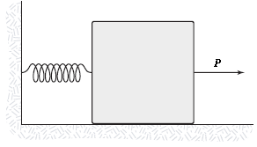

|  |  |
| --- | --- |
| **a.** | **0.85 m/s** |
| b. | 0.89 m/s |
| c. | 0.77 m/s |
| d. | 0.64 m/s |
| e. | 0.52 m/s |

9. . A 0.04-kg ball is thrown from the top of a 30-m tall building (point A) at an unknown angle above the horizontal. As shown in the figure, the ball attains a maximum height of 10 m above the top of the building before striking the ground at point B. If air resistance is negligible, what is the value of the kinetic energy of the ball at B minus the kinetic energy of the ball at A (KB  KA)?

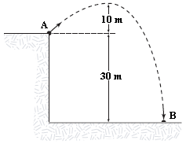

|  |  |
| --- | --- |
| **a.** | **12 J** |
| b. | 12 J |
| c. | 20 J |
| d. | 20 J |
| e. | 32 J |

10. A spring (*k* = 200 N/m) is suspended with its upper end supported from a ceiling. With the spring hanging in its equilibrium configuration, an object (mass = 2.0 kg) is attached to the lower end and released from rest. What is the speed of the object after it has fallen 4.0 cm?

|  |  |
| --- | --- |
| a. | 90 cm/s |
| **b.** | **79 cm/s** |
| c. | 96 cm/s |

11. A 1.2-kg mass is projected down a rough circular track (radius = 2.0 m) as shown. The speed of the mass at point A is 3.2 m/s, and at point B, it is 6.0 m/s. What is the change in mechanical energy done on the system between A and B by the force of friction?

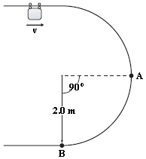

|  |  |
| --- | --- |
| a. | 8.9 J |
| b. | 7.3 J |
| **c.** | **8.1 J** |
| d. | 6.6 J |
| e. | 24 J |

12. A skier weighing 0.80 kN comes down a frictionless ski run that is circular (*R* = 30 m) at the bottom, as shown. If her speed is 12 m/s at point A, what is her speed at the bottom of the hill (point B)?

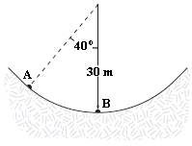

|  |  |
| --- | --- |
| **a.** | **17 m/s** |
| b. | 19 m/s |
| c. | 18 m/s |
| d. | 20 m/s |
| e. | 12 m/s |

13. A 2.0-kg object moving 5.0 m/s collides with and sticks to an 8.0-kg object initially at rest. Determine the kinetic energy lost by the system as a result of this collision.

|  |  |
| --- | --- |
| **a.** | **20 J** |
| b. | 15 J |
| c. | 30 J |
| d. | 25 J |
| e. | 5.0 J |

14. A 3.0-kg mass is released from rest at point A of a circular frictionless track of radius 0.40 m as shown in the figure. The mass slides down the track and collides with a 1.4-kg mass that is initially at rest on a horizontal frictionless surface. If the masses stick together, what is their speed after the collision?

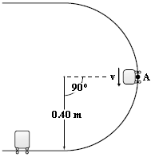

|  |  |
| --- | --- |
| a. | 2.1 m/s |
| b. | 1.7 m/s |
| **c.** | **1.9 m/s** |
| d. | 1.5 m/s |
| e. | 2.3 m/s |

15. A 2.0-kg object moving 3.0 m/s strikes a 1.0-kg object initially at rest. Immediately after the collision, the 2.0-kg object has a velocity of 1.5 m/s directed 30 from its initial direction of motion. What is the *y* component of the velocity of the 1.0-kg object just after the collision?

|  |  |
| --- | --- |
| a. | 3.7 m/s |
| b. | 3.4 m/s |
| **c.** | **1.5 m/s** |
| d. | 2.4 m/s |
| e. | 4.1 m/s |

16 . Three particles are placed in the *xy* plane. A 40-g particle is located at (3, 4) m, and a 50-g particle is positioned at (2, 6) m. Where must a 20-g particle be placed so that the center of mass of this three-particle system is located at the origin?

|  |  |
| --- | --- |
| a. | (1, 3) m |
| b. | (1, 2) m |
| c. | (1, 12) m |
| **d.** | **(1, 7) m** |
| e. | (1, 3) m |